/*
* Chris Tjon - Wed 4pm - Ex 7.9 - Elevator Program
*/
package elevator;

import java.awt.*;
import java.applet.Applet;
import java.awt.event.*;

public class Elevator extends Applet implements ActionListener
{
private Button upButton;
private Button downButton;
private boolean up;
private boolean down;

public void init ()
{
upButton = new Button("Up");
add(upButton);
upButton.addActionListener(this);
downButton = new Button("Down");
add(downButton);
downButton.addActionListener(this);

}

public void paint (Graphics g)
{
if (up) // Up Button Pressed
{
showStatus("Going Up!");
g.drawRect(40, 80, 60, 100);
}
else if (down) // Down Button Pressed
{
showStatus("Going Down!");
g.drawRect(40, 180, 60, 100);
}
else // Initial Starting Position - Down
g.drawRect(40, 180, 60, 100);

}

public void actionPerformed(ActionEvent event)
{
// Determine which button was pressed & repaint
if (event.getSource() == upButton)
{
up = true;
down = false;
}
if (event.getSource() == downButton)
{
up = false;
down = true;
}
repaint();
}
}
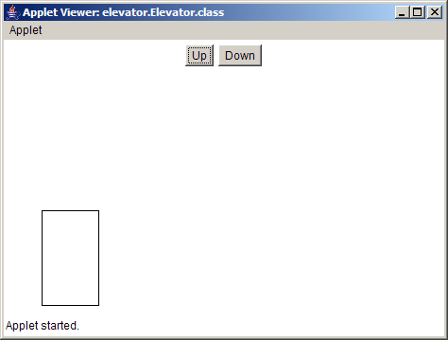
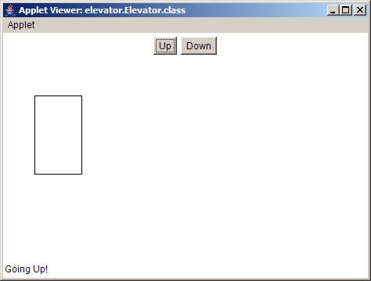

/*
* Chris Tjon - Wed 4pm - Ex 7.2 - Card Dealer
*/
package dealer;

import java.awt.*;
import java.applet.Applet;
import java.awt.event.*;

public class Dealer extends Applet implements ActionListener
{
private Button dealButton;
private String card;
private String suit; // Spades, Diamonds, Hearts, Clubs
private String value; // A,2,3,4,5,6,7,8,9,10,J,Q,K

public void init ()
{
dealButton = new Button("Deal");
add(dealButton);
dealButton.addActionListener(this);
}

public void paint (Graphics g)
{
if ((value != null) && (suit != null))
showStatus("Your Card is " + value + " of " + suit);
}

public void actionPerformed(ActionEvent event)
{
int suitNum = (int)((Math.random() * 4) + 1);
int valueNum = (int)((Math.random() * 13) + 1);

switch (suitNum)
{
case 1: suit = "Hearts"; break;
case 2: suit = "Diamonds"; break;
case 3: suit = "Spades"; break;
case 4: suit = "Clubs"; break;
}

switch (valueNum)
{
case 1: value = "Ace"; break;
case 2: value = "2"; break;
case 3: value = "3"; break;
case 4: value = "4"; break;
case 5: value = "5"; break;
case 6: value = "6"; break;
case 7: value = "7"; break;
case 8: value = "8"; break;
case 9: value = "9"; break;
case 10: value = "10"; break;
case 11: value = "Jack"; break;
case 12: value = "Queen"; break;
case 13: value = "King"; break;
}
repaint();
}
}

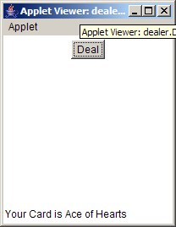

/*
* Chris Tjon - Wed 4pm - Ex 8.2 - Random Numbers in While Loop
*/
package randomnumbers;

import java.awt.*;
import java.applet.*;

public class RandomNumbers extends Applet
{

public void paint (Graphics g)
{
int numCount = 0;
double randomNum;

while (numCount < 10)
{
randomNum = Math.random();
g.drawString("Random Number "
+ (numCount + 1)
+ " is "
+ randomNum,
50, (50 + (numCount * 20)));
numCount++;
}
}
}
